Docker Complete Guide

What Is Docker?
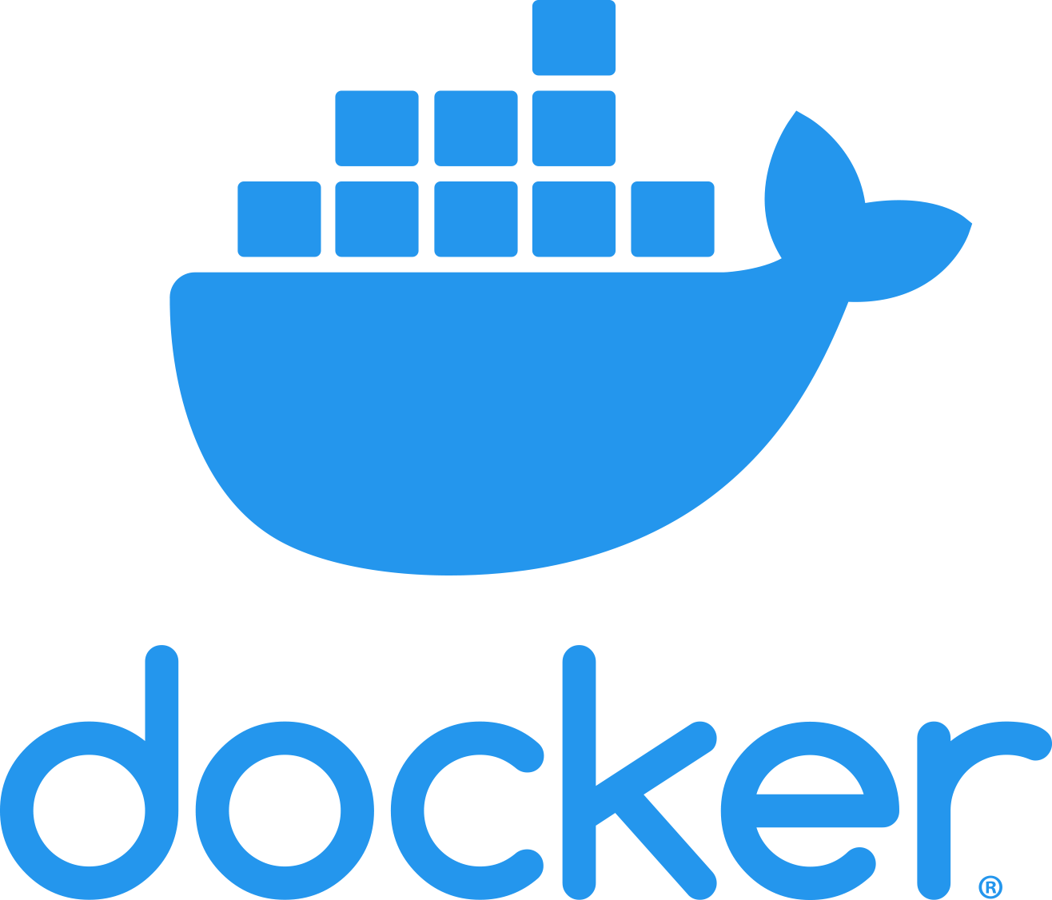
Docker is a platform for developing shipping & running applications.
Docker is a platform which packages an application and all its dependencies together in the form of container.
“Docker is technology of containerization which helps us to create multiple packages/containers & in each container we can package different dependencies & apps ”
Whats Problem Docker Solve?
A project goes through different stages like development, testing, and production. For example, if a project is built in the development (staging) stage using Java 17 but later tested in the testing stage with Java 21, it may cause errors due to version mismatch.
Solution:
Docker lets you package an application along with all its dependencies inside a container. However, containers cannot be shared directly. Instead, Docker creates an image, and this image can be shipped and run in different environments to generate containers.
Three Important Tools Of Docker :
Dockerfile, image & container
- Dockerfile: Text document which contains all the commands that a user can call on the command line to assemble an image.
- Docker Image: Template to create docker container.
- Docker Conatiner: Running instance of docker image. Containers hold entire package to run the application.
Docker Hub Link:
Docker Hub Container Image Library | App Containerization

-:DOCKER COMMANDS:-
- To Check Version:
docker –version
- To Pull The Image:
docker pull [imageName]
docker pull openjdk
docker pull [imageName]:[Tag]
docker pull openjdk:25
- To See All Images:
docker images
- To Search The Images:
docker search [imageName]
docker search python
- To Run The Images (Container Creation):
docker run [imageName]
docker run python

- To Show All Conatiner:
docker ps → shows only running containers.
docker ps -a → shows all containers, including:
  - running
  - stopped
  - exited
  - created but never started
So basically, -a (or --all) flag extends the list to every container, not just active ones
- To see all running container ids:
docker ps –q
- To Rename The Container:
docker run --name MyPythonContainer [imageName/imageId]
docker run --name MyPythonContainer python

- Interact with a container as if it were your own terminal:
docker run -it imageName
docker run -it python
Starts python container.
- Opens an interactive shell (bash).
- You can type commands inside just like on your own machine.

If you don’t use “-it”, the container may run, but:
- You won’t be able to interact with it properly.
- For example,
running docker run python without -it will just start and then exit immediately because there’s no interactive session.

- Running a container in the background instead of attaching it to your terminal:
docker run –d [imageName]

- The container runs in the background.
- -d (or --detach) flag tells Docker not to attach it to the terminal.
- You only get the container ID back.
- The container keeps running until you stop it manually
What is Attached Mode?
By default, when you run a container without -d (detach), it runs in attached mode.
- Your terminal is connected (“attached”) to the container’s main process.
- You see the container’s output directly.
- If you stop the terminal, the container stops too.

COMMAND:
docker run --name py11 -it -d python
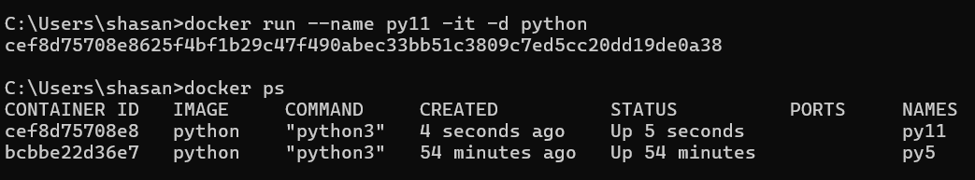
In short:
- Attached mode = you interact directly with the container.
- Detached mode = container runs in the background, free from your terminal session.

- To run a command inside an already running container.
Unlike docker run (which starts a new container), exec works on existing containers.
docker exec [options] <containerId/ name> <command>
docker exec -it a09f440d2bc3 jshell
✅ In short:
Use docker exec to run commands in running containers.
Most common use: docker exec -it <container> sh (get a shell inside)

Using MySQL Running Container
Steps
docker run --name mysql1 -e MYSQL_ROOT_PASSWORD=root -d mysql
docker exec -it msql1 bash
docker exec -it mysql1 bash
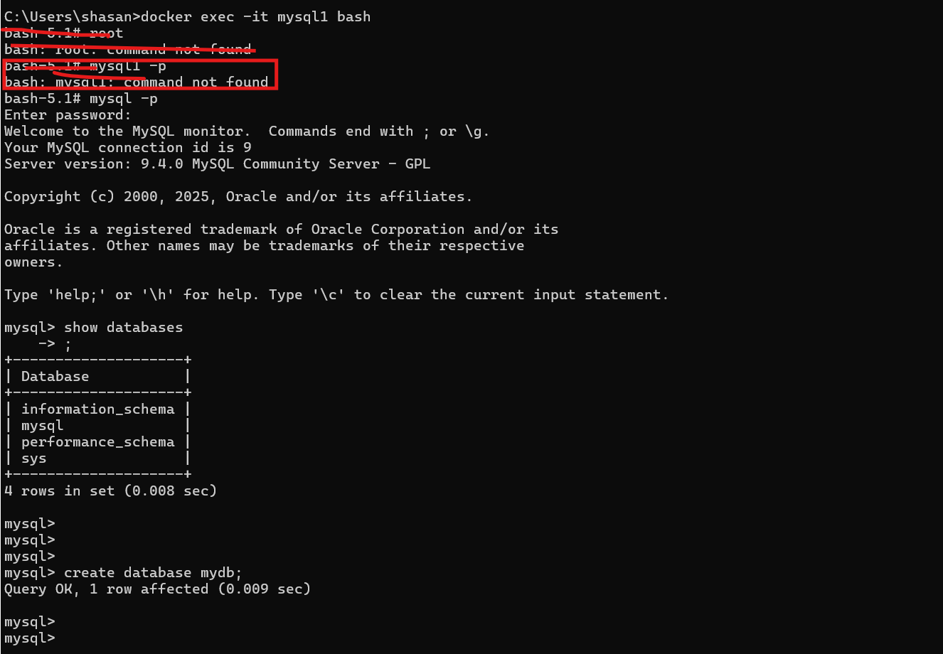
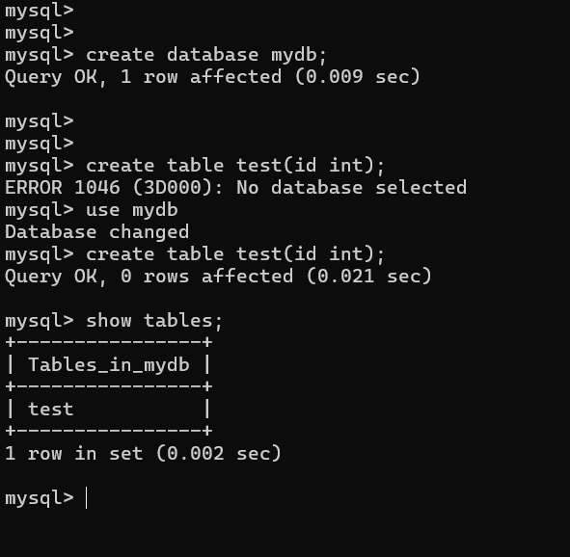
- To Check Container Logs:
docker logs <container_id>

- To Show detailed information about Docker objects in JSON format.
You can use it to inspect:
- Containers
- Images
- Networks
- Volumes
docker inspect [containerId/imageId/volumeId/networkId]
✅ In short:
- docker inspect = deep info about Docker objects in JSON.
- Super useful for debugging, especially networking & volumes.

- To Stop Multiple containers:
docker container stop container1 container2
- To Stop Conatiner:
docker stop contianerId/containerName
- To remove container:
remove multiple container
docker rm containrerId Continaerid Continaerid

- To remove Images:
docker rmi imageName

- To remove multiple images:
docker rmi image1 image2 image3
- To Restart Stop Container:
docker restart containerId

- To restart multiple containers:
docker restart container1 container2 container3

- To Create Our Own Image:
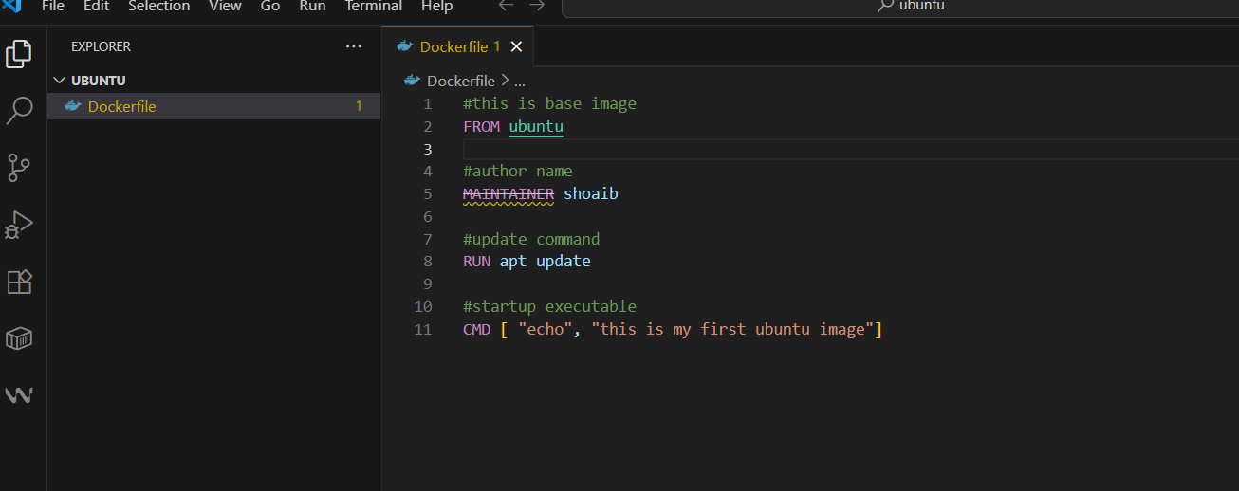
command to create an image
docker build –t <imageNmae> <directory>
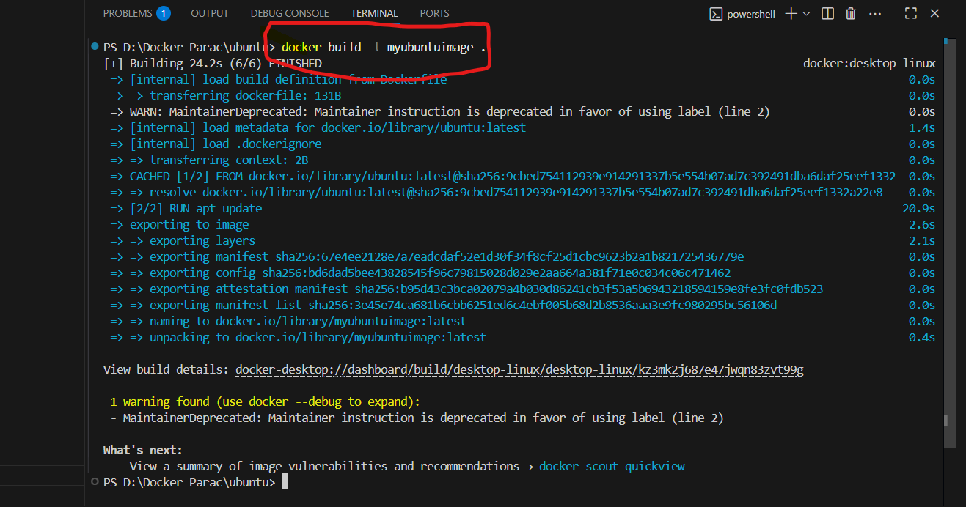
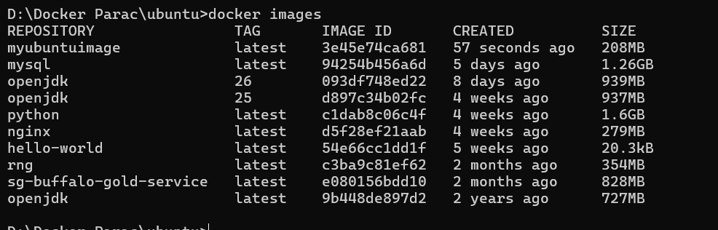

JAVA ProGRAM

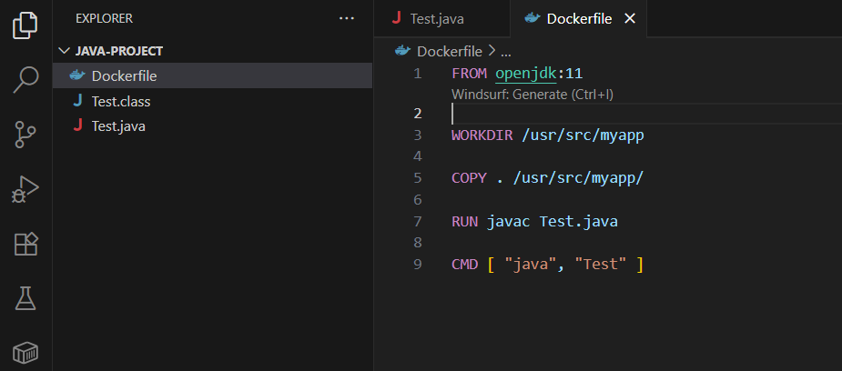
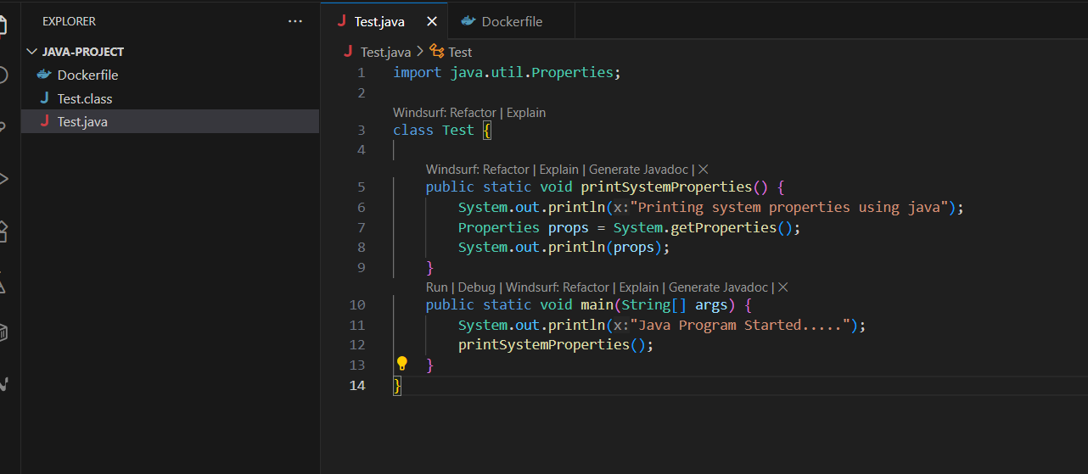
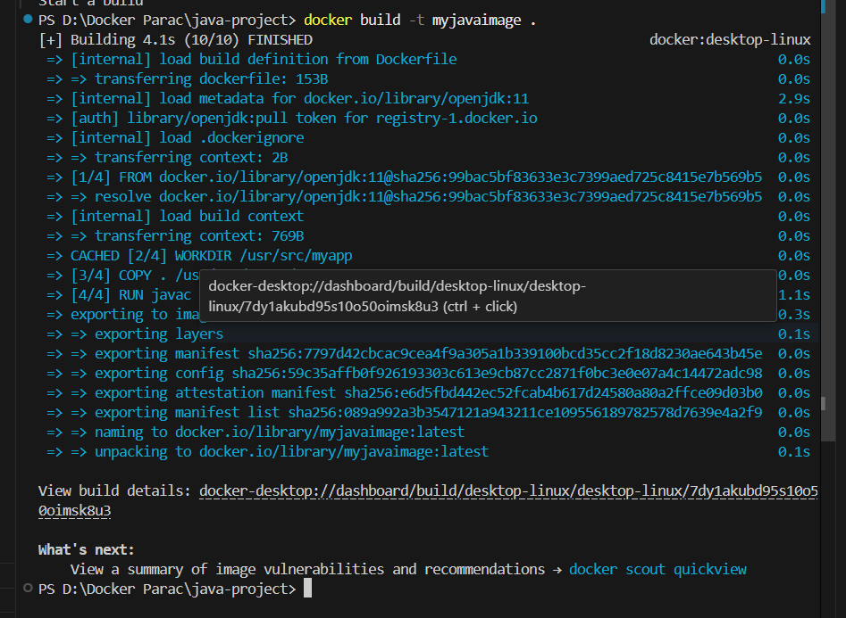
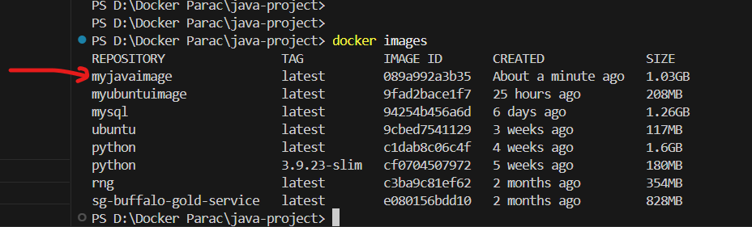

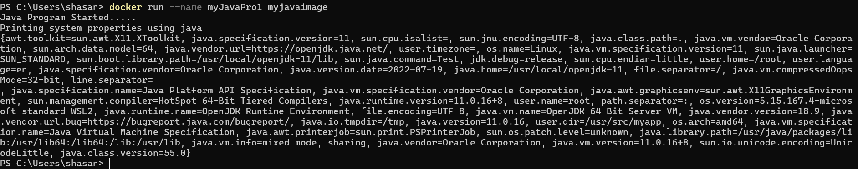
Creating Own Image Of SpringBoot App
First create a Spring Boot project. After building it, just double-click packages, and the JAR file of the application will be created inside the target folder.
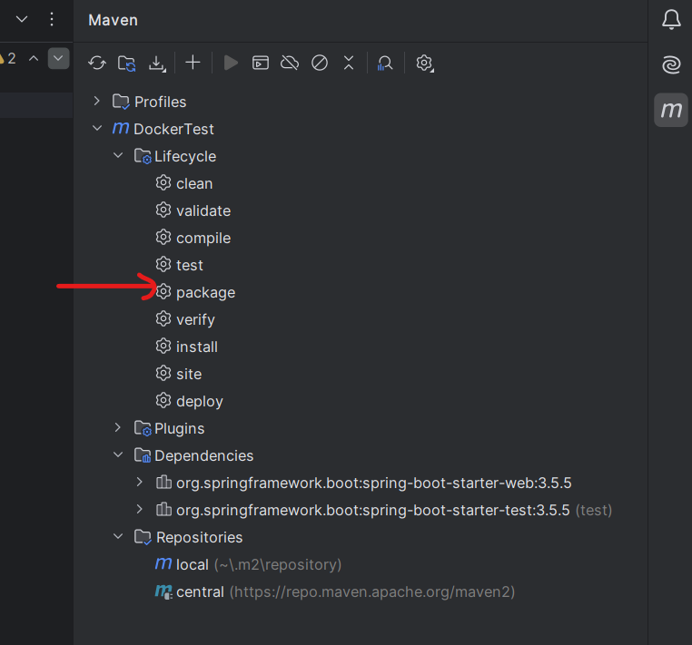
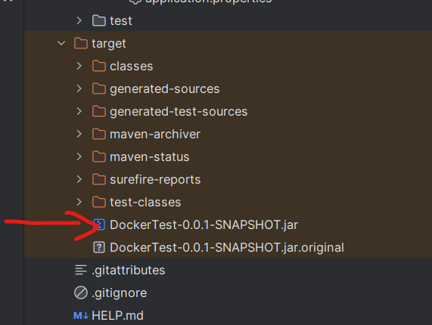
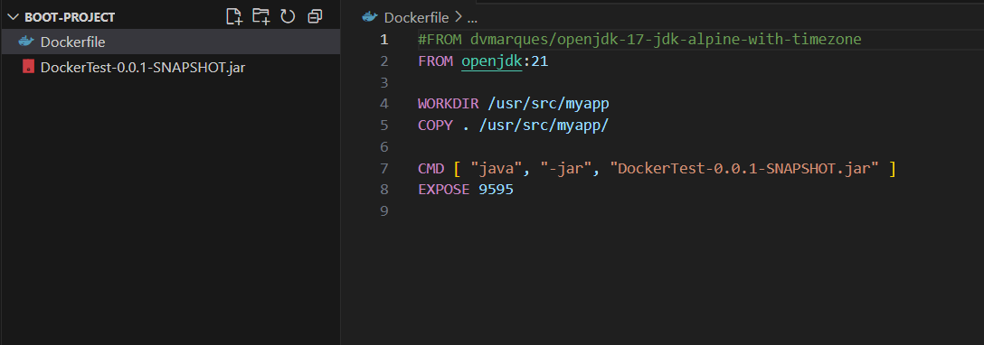
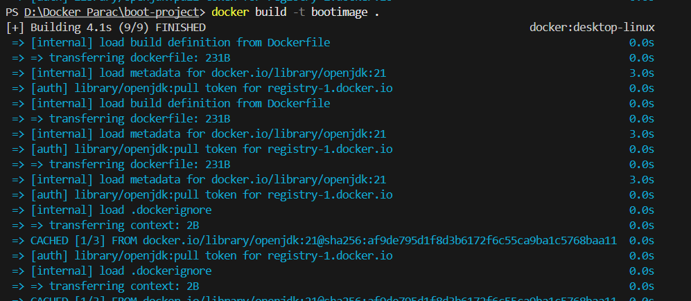
-> docker run --name bootProject2 -it -p 9595:9595 -d bootimage
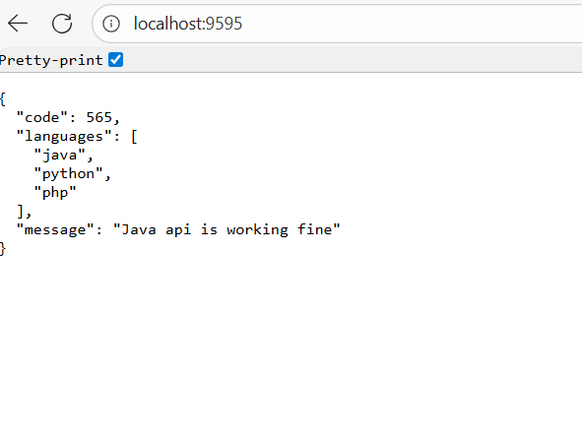

PROJECT DATABASE USING DOCKER
command:
docker run -d --name mysqldb -p 3308:3306 -e MYSQL_ROOT_PASSWORD=root -e MYSQL_DATABASE=electronic_store mysql

Docker networking: is the infrastructure Docker provides for containers to communicate with each other, the host machine, and external networks. This is achieved using various networking options and types that provide isolated or shared communication environments for containers.

- Network namespaces: Each container operates in a separate network namespace, which means it has its own network stack, including IP address, interfaces, and routing tables.
- Virtual Ethernet Devices: Docker bridges the gap between the container and host using virtual Ethernet (veth) pairs, connecting container networks to the outside world through the host.
- Bridges: The default Docker bridge network is like a private switch that lets containers communicate securely and isolates them from the host unless connections are explicitly specified.
- Port mapping: Docker exposes container services to the host by mapping container ports to host ports (e.g., -p 8080:80 maps port 80 in the container to port 8080 on the host).
- DNS resolution: Docker includes an internal DNS server so containers on the same network can find each other by name, simplifying inter-container connectivity.
Docker Network Drivers (Types)
Type | Description
bridge | Default on single hosts; containers get unique IPs and can talk to each other on the same bridge
host | Uses the host’s own network stack, so containers share the host IP and ports
none | Disables networking for the container; good for security or when network access isn’t needed
overlay | Allows containers across multiple Docker hosts to communicate; used in Docker Swarm setups
macvlan | Makes containers appear as physical devices on the network, each with its own MAC address
ipvlan | Similar to macvlan but with different efficiency characteristics
- Containers can be attached to single or multiple networks, and Docker abstracts much of the complexity for typical use-cases while allowing deep customization for advanced networking needs.
- Overall, Docker networking facilitates secure, flexible, and robust connectivity between containerized services, the host, and the outside world.

- Check Networks
docker network ls
Example output:
NETWORK ID NAME DRIVER SCOPE
abcd1234efgh bridge bridge local
ijkl5678mnop host host local
qrst9012uvwx none null local

- Inspect a Network
docker network inspect bridge
- Create a Custom Network
docker network create my_network

- Run a Container in a Specific Network
docker run -dit --name container1 --network my_network alpine sh
docker run -dit --name container2 --network my_network alpine sh
Now both containers can communicate using container name as hostname:
docker exec -it container1 ping container2
- Connect a Container to Another Network
docker network connect my_network container1

- Disconnect a Container from a Network
docker network disconnect my_network container1
- Remove a Network
docker network rm my_network
📊 Summary of Useful Commands:
Command | Purpose
docker network ls | List networks
docker network inspect <name> | Inspect details
docker network create <name> | Create a new network
docker run --network <name> | Run container in specific network
docker network connect <net> <container> | Attach container to network
docker network disconnect <net> <container> | Detach container
docker network rm <name> | Remove network

How To Create A Network & Placed Two Different Container Inside A Network So That Those Containers Can Communicater With Each Other:
Follow below steps:
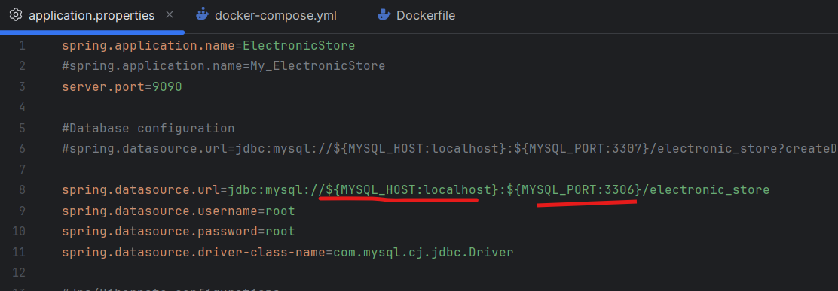
Docker File Of App
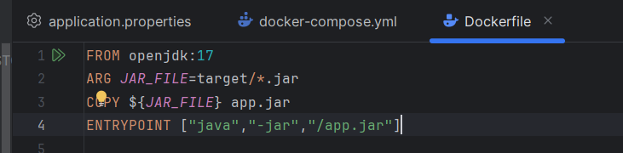
Creagte .jar file by clicking double click on package
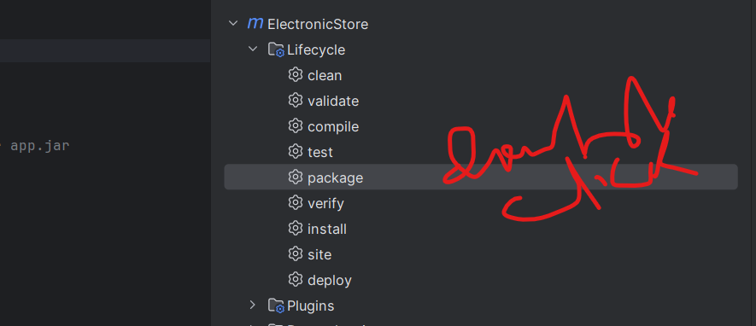
Create Image of App
>>docker build -t electronicstore .
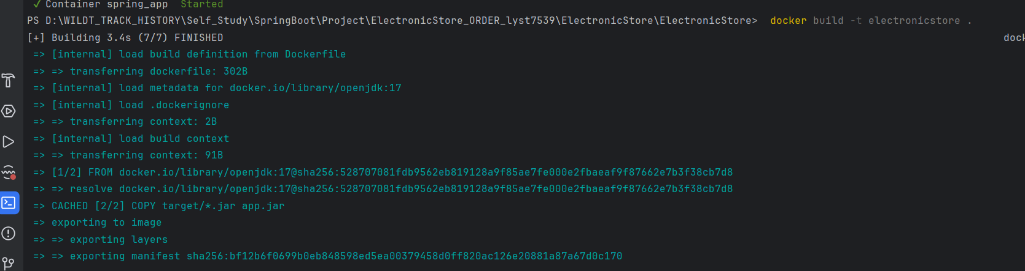
Create A Network in cmd
>>>>docker network create bootApp
Create a container of mysql under a network ”bootApp”
>>>>docker run -d --name mysqldb -p 3308:3306 --network=bootApp -e MYSQL_ROOT_PASSWORD=root -e MYSQL_DATABASE=electronic_store mysql
Create a container of springbot application under a network ”bootApp”
>>>>docker run -it --name store -p 9091:9090 --network=bootApp -e MYSQL_HOST=mysqldb -e MYSQL_PORT=3306 electronicstore

What is a Docker Volume?
- By default, when you run a container, all its data is stored inside the container’s writable layer.
- If the container stops or is deleted, the data is lost.
- To persist data, Docker provides volumes (or bind mounts).
- Volumes store data outside the container lifecycle but can still be mounted into containers.
👉 For a Spring Boot + MySQL app:
- MySQL container → needs a volume so that database data survives even if the container restarts.
- Spring Boot app → usually doesn’t need a volume (unless you want to hot-reload code or logs).
Example Setup: Spring Boot + MySQL with Docker Volumes
- Let’s say you have:
- A Spring Boot app packaged as ElectronicStore-0.0.1-SNAPSHOT.jar
- A MySQL database
- We’ll use docker-compose to run them together.
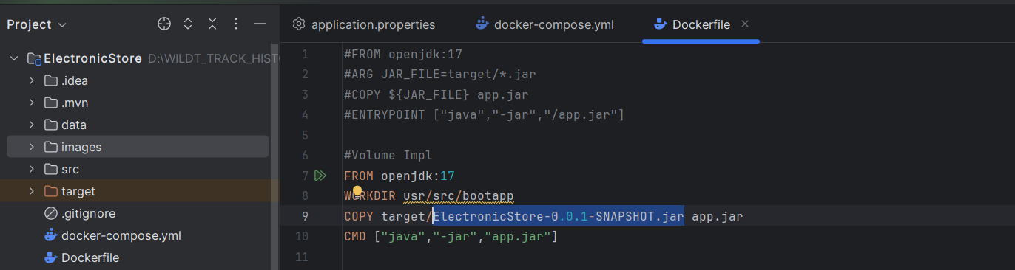
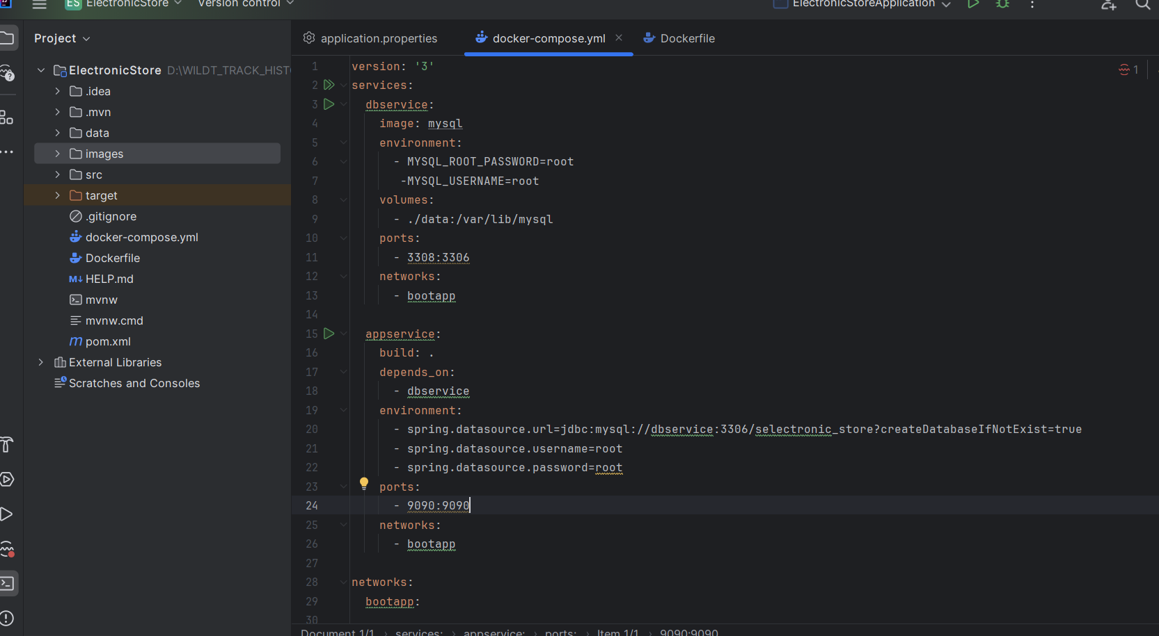
Create Image
>>>>docker build -t electronicstore .
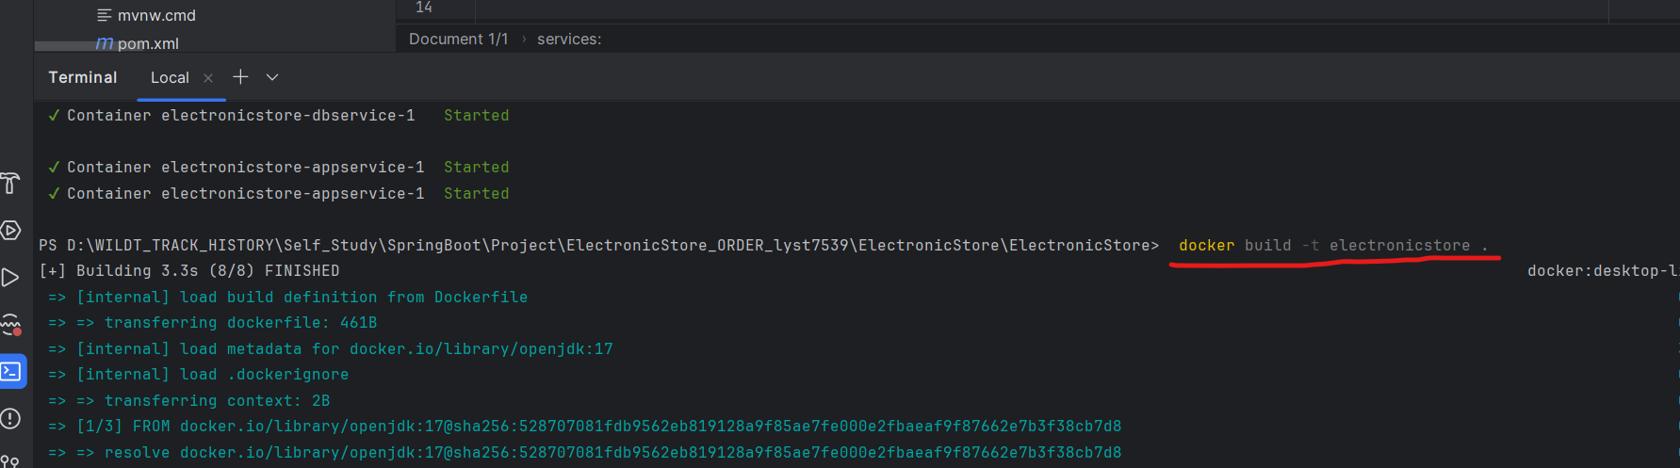

We’ll use docker-compose to run them together.
>>> docker-compose up --build -d
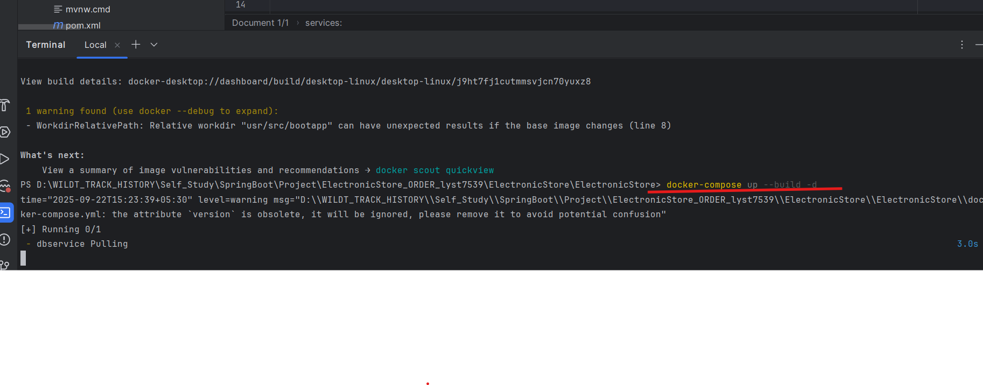
🔹 Why docker-compose.yml?
When working with multi-container apps (like Spring Boot + MySQL), you could run everything using docker run ... commands, but:
- You’d have to remember long commands with environment variables, ports, and volumes.
- You’d need to start containers in the right order (DB before app).
- Managing multiple services becomes messy.
👉 Docker Compose solves this by letting you define everything in a single YAML file:
- Services (app, database, cache, etc.)
- Networks
- Volumes
- Environment variables
Benefits of YAML (docker-compose)
- Declarative → Just describe what you want (services, volumes, ports) and Docker handles the rest.
- Reusable → Easy for teams to share config (docker-compose.yml checked into Git).
- Simple startup → docker-compose up -d runs everything in correct order.
- Scalable → You can scale services easily:
docker-compose up --scale app=3
(Runs 3 instances of your Spring Boot app).

✅ In short:
We take a .yml file because it makes multi-container apps easier to define, run, and manage.

1. Introduction to Docker
Docker is a platform that enables developers to build, run, and manage applications inside lightweight, portable containers. Containers package an application along with all its dependencies, ensuring it runs consistently across different environments.
Benefits of Docker:
- - Consistency across environments
- - Lightweight compared to virtual machines
- - Easy scaling and orchestration
- - Faster deployment cycles

2. Docker Architecture
Key components of Docker:
• Images: Read-only templates used to create containers.
• Containers: Running instances of Docker images.
• Networks: Allow containers to communicate with each other.
• Volumes: Used to persist data outside the container’s lifecycle.

3. Docker Commands with Examples
Basic Docker commands:
docker run hello-world → Run your first container
docker ps → List running containers
docker ps -a → List all containers (including stopped)
docker stop <id> → Stop a running container
docker rm <id> → Remove a container
docker images → List available images
docker rmi <id> → Remove an image

4. Networking in Docker
Docker provides different network drivers:
• bridge: Default network, used for containers on the same host.
• host: Removes network isolation between container and host.
• none: Completely disables networking for a container.
• overlay: Enables communication between multiple Docker hosts.
Example: Create a custom bridge network
docker network create my-network
Run containers inside this network:
docker run -dit --network my-network alpine sh
docker run -dit --network my-network alpine sh

5. Docker Compose (Basic Intro)
Docker Compose is a tool that allows you to define and manage multi-container applications using a YAML file (`docker-compose.yml`). It simplifies running multiple containers that depend on each other.
Example docker-compose.yml:
version: '3'
services:
web:
image: nginx
ports:
- "8080:80"
db:
image: mysql
environment:
MYSQL_ROOT_PASSWORD: root

6. Useful Tips
- Always clean up unused images and containers using `docker system prune`.
- Use volumes for persistent data (e.g., databases).
- Use `docker logs <container>` to debug container issues.
- For production, consider orchestration tools like Kubernetes or Docker Swarm.

